CYC_WAKE

Revision History

|  |  |  |  |
| --- | --- | --- | --- |
| Revision Number | Date | Description of Change | Author |
| V0.0 | 9/22/2022 | Draft version | Su Aixue |

Table of Contents

CYC_WAKE 2

Introduction 2

Register Definition 2

Register Map 2

MON_CONF 2

ADC_CTRL 3

Function Details 3

Block Diagram 3

CYC_WAKE IO Descriptions 4

CYC_WAKE Key Signal Descriptions 5

CYC_WAKE Function Descriptions 5

# CYC_WAKE

## Introduction

The CYC_WAKE is a simple, periodic pulse generator. The period of the output wake can be programmed. In other words, the CYC_WAKE can generate square wave with various frequency.

The CYC_WAKE module has the following features:

• Latch MON_EN_REG, MON_WAKE_PERIOD_REG to MON_EN, MON_WAKE_PERIOD once MON_WAKE_GO is high; (HWR001_CYC_WAKE)

• Output clr_MON_WAKE_GO high (lasting 1 CLK_SLOW) after register latched done; (HWR002_CYC_WAKE)

• Output MON_ADC_GO according to MON_WAKE_PERIOD; (HWR003_CYC_WAKE)

• When D2A_CELL_ADC_EN is high, MON_ADC_GO will be low; (HWR003_CYC_WAKE)

• MON_ADC_GO can be cleared by clr_ADC_GO; (HWR003_CYC_WAKE)

• Output MON_WAKE according to MON_WAKE_PERIOD; (200ms-3.2s, step 200ms; 3.2s-156.8s, step 3.2s) (HWR004_CYC_WAKE)

• MON_WAKE can be cleared by RR_END; (HWR004_CYC_WAKE)

• MON_WAKE shall be high earlier 10ms than MON_ADC_GO. (HWR004_CYC_WAKE)

## Register Definition

### Register Map

Table 1 CYC_WAKE Register Map

|  |  |  |  |
| --- | --- | --- | --- |
| **ADDRESS** | **NAME** | **DESCRIPTION** | **RESET VALUE** |
| **CYC_WAKE** | | | |
| 0x0000 | **MON_CONF** | CYC_WAKE configuration register | 0x45 |
| 0x1FF7 | **ADC_CTRL** | ADC control register | 0x00 |

### MON_CONF

Register 1. MON_CONF (CYC_WAKE configuration register, offset 0x0000)

|  |  |  |  |  |
| --- | --- | --- | --- | --- |
| **BIT** | **NAME** | **ACCESS** | **RESET** | **DESCRIPTION** |
| 7:2 | **MON_WAKE_PERIOD** | R/W | 6’h11 | Period Configuration  00 0000: 0.2s  00 0001: 0.4s  00 0010: 0.6s  …  00 1111: 3.2s  01 0000: 6.4s  01 0001: 9.6s  01 0010: 12.8s  …  11 1111: 156.8s |
| 1 | **REV** | R | 1’b0 | Reserved |
| 0 | **MON_WAKE_EN** | R/W | 1’b1 | CYC_WAKE Enable Bit  0: Disable  1: Enable |

### ADC_CTRL

Register 11. ADC_CTRL (ADC control register, offset 0x1FF6)

|  |  |  |  |  |
| --- | --- | --- | --- | --- |
| **BIT** | **NAME** | **ACCESS** | **RESET** | **DESCRIPTION** |
| 7 | **MON_WAKE_GO** | R/W | 1’b0 | Mon-wake Starting Bit  0: Ready  1: Execute |
| 6:3 | **REV** | R | 4’h0 | Reserved |
| 2:0 | **--** | -- | -- | -- |

## Function Details

### Block Diagram

The main elements of CYC_WAKE and their interactions are shown in Fig 1.



Fig 1. CYC_WAKE Block Diagram

### CYC_WAKE IO Descriptions

This section provides the CYC_WAKE IO descriptions.

Table 2 CYC_WAKE IO descriptions

|  |  |  |  |  |  |
| --- | --- | --- | --- | --- | --- |
| **Signal** | **Width** | **Duration** | **I/O** | **Default Value** | **Register** |
| CLK_SLOW_SC | 1 | -- | I | -- | -- |
| resetb_SR_CLK_SLOW | 1 | -- | I | -- | -- |
| MON_WAKE_GO | 1 | 1~2 CLK_SLOW_SC | I | -- | MON_WAKE_GO |
| MON_EN_REG | 1 | -- | I | -- | MON_WAKE_EN |
| MON_WAKE_PERIOD_REG | 1 | -- | I | -- | MON_WAKE_PERIOD |
| D2A_CELL_ADC_EN | 1 | 43874 CLK_REG_SC | I | -- | -- |
| clr_ADC_GO | 1 | 16 CLK_ADC_SC | I | -- | -- |
| RR_END | 1 | 16 CLK_ADC_SC | I | -- | -- |
| clr_MON_WAKE_GO | 1 | 1 CLK_SLOW_SC | O | 1’b0 | -- |
| MON_WAKE | 1 | 4017 CLK_SLOW_SC | O | 1’b0 | -- |
| MON_ADC_GO | 1 | 4 CLK_SLOW_SC | O | 1’b0 | -- |

### CYC_WAKE Key Signal Descriptions

Table 3 CYC_WAKE key signal descriptions

|  |  |  |  |  |
| --- | --- | --- | --- | --- |
| **Signal** | **Width** | **Duration** | **Default Value** | **Description** |
| time_val | 32 | -- | 32’h2580 | When MON_EN = 1, the value of this signal is the duration corresponding to the MON_WAKE_PERIOD_REG. This signal is used to store the period of the MON_WAKE output signal. |
| mon_wake_per | 32 | -- | 32’h264398 | The value of this signal is the clock periods’ number corresponding the time_val. |
| clr_MON_WAKE_GO | 1 | 1 CLK_SLOW_SC | 1’b0 | The clr_MON_WAKE_GO is a pulse lasting for a clock period. When “MON_WAKE_GO = 1” is detected, the clr_MON_WAKE_GO pulse will generate at the rising edge of the next clock. This signal is an output signal, and is used to clear the MON_WAKE_GO. |
| MON_WAKE | 1 | 4017 CLK_SLOW_SC | 1’b0 | When MON_EN = 1 and clr_MON_WAKE_GO = 1, the first rising edge of MON_WAKE will be generated, and MON_WAKE is cleared by the next RR_END_SYNC (RR_END after synchronization). The second and the subsequent rising edge of MON_WAKE is generated at the moment when the following signal count1 = mon_wake_per and MON_EN = 1. It is an output signal and it is a periodic signal. |
| mon_wake_pos | 1 | 1 CLK_SLOW_SC | 1’b0 | When the rising edge of MON_WAKE appear and MON_EN = 1, the pulse of mon_wake_pos (width = 1 clock period) is generated. |
| mon_wake_start | 1 | -- | 1’b0 | When mon_wake_pos = 1, mon_wake_start = 1. |
| count1 | 32 | -- | 32’b0 | When MON_EN = 1 and mon_wake_start = 1, the count1 starts to count, and count back to 0 when it is up to mon_wake_per or MON_EN = 0. |
| count2 | 12 | -- | 12’b0 | When MON_EN = 1 and mon_wake_pos = 1, the count2 starts to count, and count back to 0 when it is up to 12’h35 (corresponding to 10ms) or MON_EN = 0. This signal is used to count the time that MON_WAKE earlier than MON_ADC_GO. |

### CYC_WAKE Function Descriptions

The CYC_WAKE module has the following functions:

• Latch MON_EN_REG, MON_WAKE_PERIOD_REG to MON_EN, MON_WAKE_PERIOD once MON_WAKE_GO is high; (Func 1) (HWR001_CYC_WAKE)

• Output clr_MON_WAKE_GO high (lasting 1 CLK_SLOW) after register latched done; (Func 2) (HWR002_CYC_WAKE)

• Output MON_ADC_GO according to MON_WAKE_PERIOD; (Func 3) (HWR003_CYC_WAKE)

• When D2A_CELL_ADC_EN is high, MON_ADC_GO will be low; (Func 4) (HWR003_CYC_WAKE)

• MON_ADC_GO can be cleared by clr_ADC_GO; (Func 5) (HWR003_CYC_WAKE)

• Output MON_WAKE according to MON_WAKE_PERIOD; (200ms-3.2s, step 200ms; 3.2s-156.8s, step 3.2s) (Func 6) (HWR004_CYC_WAKE)

• MON_WAKE can be cleared by RR_END; (Func 7) (HWR004_CYC_WAKE)

• MON_WAKE shall be high earlier 10ms than MON_ADC_GO. (Func 8) (HWR004_CYC_WAKE)

Above functions can be found in the following timing diagram. Fig 3 and Fig 4 are magnified version of Fig 2.

Func 1: Sample the value of MON_WAKE_GO using CLK_SLOW_SC. When the high level of MON_WAKE_GO is detected, the value of MON_EN and MON_WAKE_PERIOD will be set to the value of MON_EN_REG and MON_WAKE_PEEROD_REG.

Func 2: Sample the value of MON_WAKE_GO, MON_EN_REG, MON_EN, MON_WAKE_PERIOD_REG, MON_WAKE_PERIOD using CLK_SLOW_SC. When the high level of MON_WAKE_GO is detected, and the value of MON_EN/MON_WAKE_PERIOD being equal to MON_EN_REG/MON_WAKE_PERION_REG is detected at the same time, the clr_MON_WAKE_GO will be set to 1. Besides, sample the value of clr_MON_WAKE_GO using CLK_SLOW_SC. When the high level of CLK_SLOW_SC is detected, the value of clr_MON_WAKE_GO will be cleared.

Func 3: At the beginning, convert the value of MON_WAKE_PERIOD convert to timing value, and then covert the timing value convert the counts of clock cycles. Finally, generate a periodic wave (MON_ADC_GO) using counting method.

Func 6: Similar to Func 3.

Func 8: Implement it using counting method.

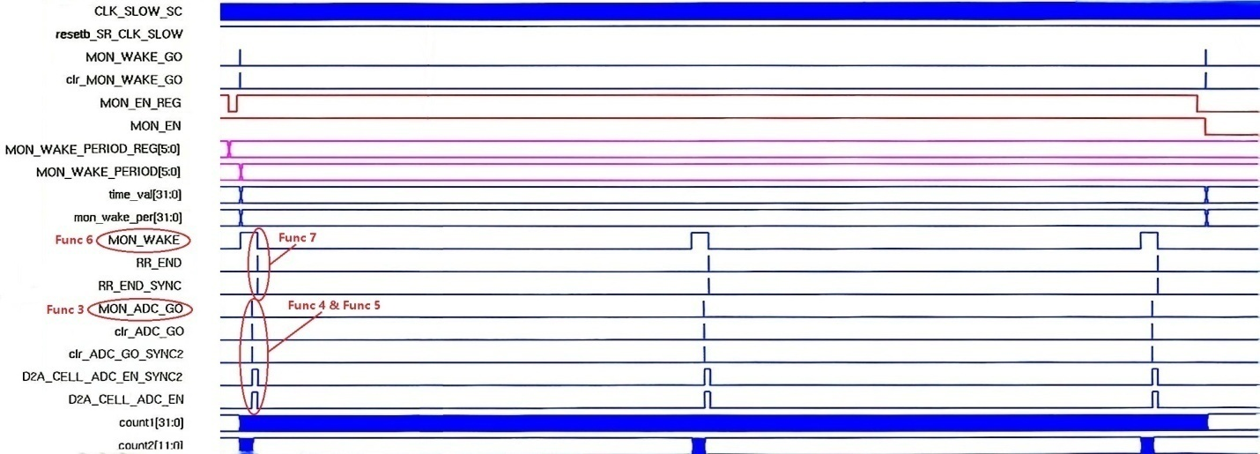

Fig 2. CYC_WAKE Timing Diagram 1

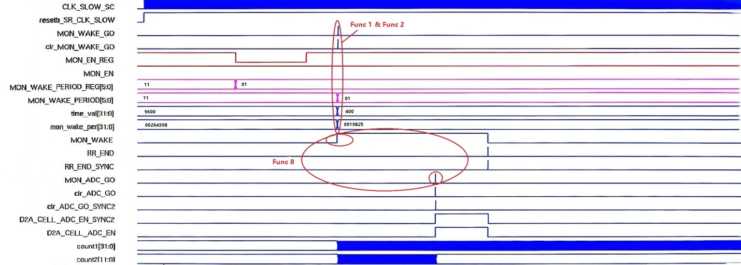

Fig 3. CYC_WAKE Timing Diagram 2

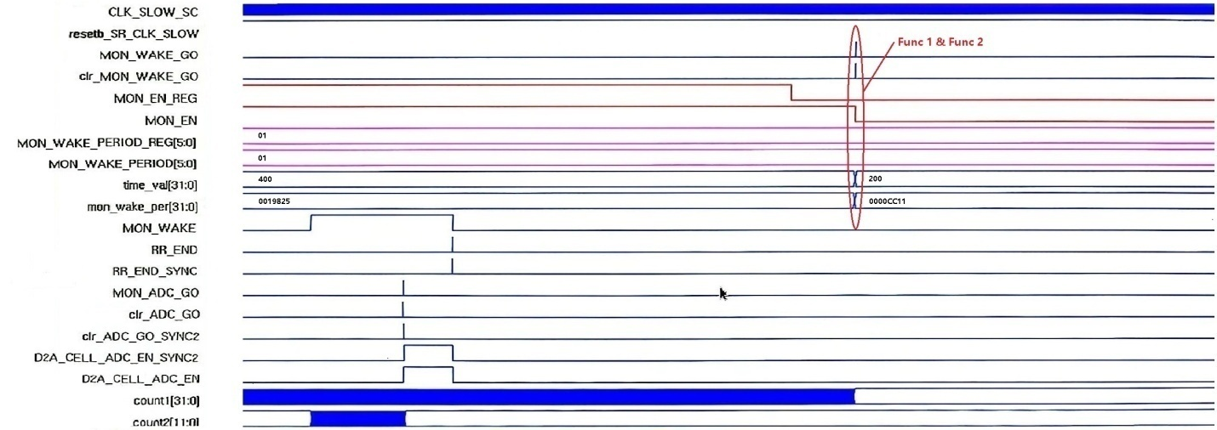

Fig 4. CYC_WAKE Timing Diagram 3